PROJECT REPORT
ON

“Loan Approval Prediction System”

Submitted By
Devanshi Shah (SOE2022B0306033)
Sonal Gawas (SOE2022B0306040)
Neel Vaghasiya (SOE2022B0306081)
Onkar Jadhav (SOE2022B0306085)

D Y PATIL UNIVERSITY PUNE AMBI
BACHELOR OF TECHNOLOGY (INFORMATION TECHNOLOGY)

SCHOOL OF ENGINEERING & TECHNOLOGY
2025-2026

CERTIFICATE

This is to certify that the report entitled

“Loan Approval Prediction-Using ML”

Submitted By
Devanshi Shah (SOE2022B0306033)
Sonal Gawas (SOE2022B0306040)
Neel Vaghasiya (SOE2022B0306081)
Onkar Jadhav (SOE2022B0306085)

Is a project work carried out by the supervision of

Dr. Vivek Patil

And it is submitted towards the partial fulfilment of BACHELOR OF TECHNOLOGY (INFORMATION TECHNOLOGY) through the D Y Patil University Pune Ambi during Academic year 2025-2026

Dr. Vivek Patil  Project Guide |  | Sofia Mujavar  Head of Department

DECLARATION

This declaration is part of the Synopsis for project work entitled Loan Approval Prediction is submitted as part of academic requirement for Semester V of BCA TY Management to the D. Y. Patil University SCHOOL OF ENGINEERING & TECHNOLOGY Ambi, Pune.
I, Onkar Jadhav solely declare that

- I will not use any unfair means to complete the project.
- I will follow the discipline and the rules of the organization where I am doing the project.
- I will not do or be part of any act which may impact the college reputation adversely.

The information I have given is true, complete and accurate. I understand that failure to give truthful, incomplete and inaccurate information may result in cancellation of my project work.

Date:

Place: Name and Signature of Student

ACKNOLEGMENT

This is a great pleasure and immense satisfaction to express my deepest sense of gratitude and thanks to everyone who has directly or indirectly helped me in completing my project successfully.

I express my Gratitude toward my project guide Dr. Sunita Jadhav and Prof. Vishal Chavan DY Patil University Pune, Ambi who guided and encouraged me in completing the project work in schedule time.

No words are sufficient to express my Gratitude to my parents for their unweaving encouragement. I am grateful to my friends for their patience and always supporting me throughout my project

Yours Sincerely,
Onkar Jadhav

ABSTRACT

Loan Approval Prediction System

This project details the design and implementation of a robust classification model utilizing Machine Learning (ML) techniques to accurately predict the eligibility of loan applicants. The primary objective is to mitigate financial risk for banking institutions by automating the validation process and reducing Non-Performing Assets (NPAs).
The methodology follows a structured ML pipeline: raw applicant data undergoes rigorous Data Validation (checking for insolvency and regulatory compliance) and is processed via Feature Engineering to derive critical financial metrics like 'Balance Income' and 'Stability Score'. A powerful ensemble algorithm, the Random Forest Classifier, is selected for its superior ability to handle high-dimensional demographic and financial data.
The system features a unique Two-Layer Architecture: a primary layer of financial guardrails that filters out mathematically non-viable applications, followed by a secondary ML prediction layer for behavioral risk assessment. The core result is a highly accurate, serialized prediction pipeline (.pkl file) deployed via a user-friendly Streamlit web interface, offering instant, transparent, and data-driven loan decisions.

INDEX
S.No. | Table of Content | Page No. | Remark
1. | CHAPTER 1: INTRODUCTION  - Existing System and Need for System  - Scope of Work  - Operating Environment  - Detailed Description of Technology Used | 1-8
2. | CHAPTER 2: PROPOSED SYSTEM  - Proposed System  - System Overview  - Feasibility Study | 9-14
3. | CHAPTER 3: ANALYSIS & DESIGN  - Object Diagram  - Class Diagram  - Use Case Diagram  - Module Hierarchy Diagram  - Component Diagram  - Module Specification  - User Interface Design  - Test Procedures and Implementation | 15-25
4. | CHAPTER 4: USER MANUAL  - User Manual  - Operations Manual / Menu Explanation  - Forms and Report Specifications | 26-29
5. | Drawbacks and Limitations | 30-31
6. | Proposed Enhancements | 32-33
7. | Conclusion | 34-35
8. | Bibliography | 36
9. | ANNEXURE 1: Sample Program Code | 37-40

CHAPTER 1: INTRODUCTION

The banking and financial services sector constitutes the economic backbone of any nation, facilitating growth by providing essential credit to individuals, businesses, and industries. One of the core functionalities of any banking institution is the provision of loans, which serves as a primary revenue stream. However, this function is accompanied by a significant inherent risk: Credit Risk. This refers to the probability that a borrower may default on their repayment obligations, leading to financial losses for the institution.
In the traditional banking model, the process of assessing a loan application—known as Underwriting—has been a manual, labor-intensive task. Loan officers are required to meticulously verify physical documents, analyze income statements, check credit scores manually, and rely on their subjective judgment to approve or reject a loan. This human-centric approach, while foundational, is fraught with inefficiencies in the modern digital age. It is often characterized by slow processing times, inconsistency in decision-making, and a susceptibility to human error or bias.
With the advent of Fintech (Financial Technology) and Artificial Intelligence, there is a paradigm shift towards automating these critical decision-making processes. Machine Learning (ML) offers a powerful solution by enabling systems to learn from historical data. This project, titled "Loan Prediction System using Machine Learning," aims to revolutionize the credit assessment process. By leveraging advanced algorithms like the Random Forest Classifier, the system replaces subjective manual evaluation with an objective, statistical, and data-driven approach. This ensures that banks can process applications in real-time while significantly reducing the risk of Non-Performing Assets (NPAs).

  - Existing System and Need for System

Existing System The evaluation of loan eligibility has historically relied on methods that, while foundational, present significant limitations in the context of modern banking complexity and volume. These existing approaches struggle to provide the speed, objectivity, and accuracy required by today's financial institutions.
- Static and Simplistic Models: Traditional methods often employ simple rule-based software or manual underwriting criteria. These systems assume linear relationships between financial health and repayment capacity. They often oversimplify complex profiles; for instance, they might reject a high-potential applicant solely based on a single metric like "Self-Employed" status, failing to capture the non-linear patterns present in the data, such as the stability provided by a high co-applicant income.
- Subjectivity and Time Constraints: The process of manual verification and credit assessment is subjective and highly dependent on the loan officer's expertise and judgment. Furthermore, it is a slow process that cannot be scaled to process thousands of applications instantaneously, which is a major drawback for high-volume banking periods and real-time digital lending platforms.
- Ineffective Feature Handling: Traditional legacy systems struggle when datasets contain a high number of diverse feature types, including categorical variables (like Education or Property Area) and numerical variables with wide-ranging scales. If not properly encoded and normalized, these features can lead to biased decisions where one factor disproportionately influences the outcome.
Need for the Proposed ML System To overcome the inherent limitations of simplicity, slowness, and subjectivity, the proposed Machine Learning Loan Prediction System is essential. It leverages modern algorithms and rigorous data science techniques to provide superior performance.
- Advanced Predictive Accuracy: The use of Ensemble Learning Algorithms, specifically the Random Forest Classifier, is required because these models have been proven to have lower error rates and provide more robust predictions than traditional logistic regression methods. Random Forest minimizes the risk of overfitting by aggregating the decisions of multiple decision trees.
- Robust Handling of Data Complexity: ML pipelines allow for systematic data cleaning and preprocessing, including addressing missing values (e.g., substituting the mean for Loan Amount or mode for Gender) and encoding categorical features using methods like Label Encoding. This ensures that all features, whether numerical or categorical, are properly represented and contribute fairly to the model training.
- Objectivity and Scalability: The final, trained model offers objective assessment, as predictions are based purely on learned statistical relationships and model logic, free from human bias. Once trained and saved, the model can be deployed as a web application, providing instantaneous, high-volume predictions, which is critical for modern fintech services.

  - Scope of Work

The scope of work for the Loan Prediction ML project meticulously defines the project's boundaries, objectives, and deliverables, ensuring a focused effort on building a high-performing classification model.
Functional Scope: Model Capability This scope defines what the final machine learning model must be capable of doing:
- Prediction: The model must predict a binary categorical value (Approved or Rejected) based on the input features. The project strictly addresses a classification problem.
- Feature Interpretation: The system must interpret and incorporate a diverse set of input characteristics, including Income, Loan Amount, Credit History, and Education, as these are crucial factors influencing repayment probability.
- Non-Linear Modeling: The final selected model must utilize an advanced machine learning technique (the Random Forest Classifier) to capture the complex, non-linear relationships between applicant attributes and loan status.
- Generalization: The model must achieve a predetermined level of accuracy (defined by metrics like Accuracy Score) on unseen test data to prove its ability to generalize to new applicants.

Technical Scope: ML Pipeline and Deliverables This scope covers the technical tasks and the resulting assets that will be produced:
- Data Preprocessing: The project includes the mandatory steps of handling missing values (Imputation), managing outliers (Constraint Validation), and encoding categorical variables for modeling.
- Feature Engineering: The creation of new, predictive features (e.g., Balance_Income, Total_Income) to enhance model performance is within scope.
- Model Training and Selection: The project will train the Random Forest Classifier and optimize it using hyperparameters (e.g., n_estimators=200) to achieve optimal performance.
- Evaluation: The performance must be quantified using standard classification metrics, primarily Accuracy and the Confidence Score.
- Model Persistence: The final deliverable is the serialized, trained model object (a .pkl file) which encapsulates both the preprocessing logic and the final classifier, ready for deployment.
  - Operating Environment

The operating environment is divided into two distinct profiles: the requirements for Model Training and Development and the requirements for Model Deployment (Inference).

Model Training and Development Environment This environment requires sufficient resources to handle datasets, execute statistical operations, and run iterative training processes.
- Hardware (Recommended):
  - Processor (CPU): Intel Core i5 / AMD Ryzen 5 or higher. Multiple cores are essential for parallel processing during Random Forest training.
  - Memory (RAM): 8 GB DDR4 or higher. Necessary to load the dataset into memory and prevent crashes during data manipulation and encoding operations.
  - Storage: 256 GB SSD. Solid-state storage is mandatory to ensure fast read/write speeds for loading data, saving model checkpoints, and accessing library files.
- Software:
  - Operating System: Windows 10/11, macOS, or Linux (Ubuntu).
  - Core Languages: Python 3.8+ (managed via Anaconda or standard installer).
  - Key Libraries:
    - pandas, numpy (Data Handling)
    - scikit-learn (General ML, Preprocessing, Evaluation)
    - Streamlit (Web Framework for Interface)
    - pickle (Model Serialization)

Model Deployment (Inference) Environment The deployment environment must prioritize stability and low latency for prediction requests. Since the model is already trained, the computational demands are much lower.
- Hardware (Local/Server):
  - Processor (CPU): 2 vCPUs (Virtual CPUs) on a cloud instance or standard laptop CPU. Sufficient for handling basic web traffic and fast prediction execution.
  - Memory (RAM): 4 GB RAM. Enough to load the entire serialized model file (model.pkl) into memory and serve concurrent prediction requests.
- Software:
  - Web Framework: Streamlit. Selected for creating the lightweight interactive web application.
  - Dependencies: Only the specific library versions required by the saved model (e.g., the exact version of scikit-learn used during training) to ensure prediction consistency.

  - Detailed Description of Technology Used

The Loan Prediction ML project relies on a technology stack centered on Python's data science ecosystem, which provides the tools necessary for data manipulation, rigorous preprocessing, model training, and final deployment readiness.
Core Data Science and Programming
- Python: Selected as the primary programming language due to its versatility and extensive libraries, making it a popular choice in the data science community.
- NumPy: Provides a robust foundation for numerical operations and efficient handling of multi-dimensional arrays, which form the basis of all data processing and modeling inputs.
- Pandas: The fundamental library used for data manipulation, analysis, cleaning, and transformation of the structured, tabular loan dataset (train.csv).
Preprocessing and Evaluation Framework
- Scikit-learn (sklearn): This is the core machine learning library, offering the tools for feature encoding (LabelEncoder), model selection (train_test_split), and performance evaluation (accuracy_score).
- LabelEncoder: A utility from sklearn that allows categorical text data (e.g., "Male", "Graduate") to be converted into numerical format suitable for the Random Forest algorithm.
Machine Learning Algorithm (Classifier) The project primarily relies on powerful ensemble models for high predictive accuracy:
- Random Forest Classifier: An ensemble learning method that constructs a multitude of decision trees at training time. It outputs the class that is the mode of the classes (classification) or mean prediction (regression) of the individual trees.
  - Why Selected: It is generally known for excelling in achieving higher accuracy on structured data and naturally handles non-linear relationships and interactions between features (e.g., Income vs. Loan Amount) better than single decision trees.
Deployment Readiness
- Pickle: This Python-specific module is essential for Model Serialization, which is the process of saving the entire trained pipeline to a disk file (model.pkl).
  - Purpose: Serialization ensures the exact trained model state can be easily loaded and reused for prediction without retraining, facilitating deployment.
- Streamlit: A specialized web framework used to turn data scripts into shareable web apps. It powers the frontend interface where users enter details and view the "Approved" or "Rejected" status.

CHAPTER 2: PROPOSED SYSTEM

2.1 Proposed System

he proposed system for Loan Prediction is an End-to-End Machine Learning Pipeline designed to provide objective, high-accuracy estimations of a loan applicant's eligibility status (Approved or Rejected) based on their financial profile. This structured approach ensures consistency, high predictive power, and robustness for eventual deployment.
System Goal and Algorithm Selection
The primary goal is to solve a Binary Classification task—predicting the categorical status of a loan application ($Y$) based on input features ($X$). The system proposes using the Random Forest Classifier.
- Superior Performance: Random Forest is an ensemble learning algorithm known for its superior efficiency and accuracy in handling complex, non-linear relationships in structured banking data. Unlike single decision trees that are prone to overfitting, Random Forest aggregates the votes of hundreds of trees to produce a stable and generalized decision.
- Robustness: This model consistently achieves high accuracy scores in classification tasks compared to simpler linear models like Logistic Regression.
Mandatory Data Preprocessing & Cleaning
Data quality is paramount, requiring rigorous cleaning before modeling.
- Handling Missing Values (Imputation): The system must identify and appropriately fill null values in the dataset. This involves substituting numerical missing data (e.g., Loan Amount) with the mean, and categorical missing data (e.g., Gender, Self-Employed) with the mode (most frequent value).
- Financial Guardrails (Constraint Logic): A unique feature of this proposed system is the implementation of domain-specific guardrails. Before prediction, the system validates fundamental financial viability (e.g., rejecting applicants where EMI > Income or Loan > 150x Income). This prevents the model from processing mathematically insolvent applications⁶.
- Encoding Categorical Variables: Text-based categorical features must be converted to numerical format. This is done using Label Encoding, where each category is assigned a unique integer (e.g., Male=1, Female=0).
Feature Engineering
Features must be optimized and formatted for the ML algorithm.
- Feature Creation: This involves creating new features that capture complex financial interactions. The system calculates Total Income (Applicant + Co-applicant) and Balance Income (Total Income - EMI) to give the model a clearer picture of actual repayment capacity.
- Feature Scaling: While Random Forest is robust to unscaled data, ensuring consistent scales helps in interpreting feature importance later.
Implementation Structure
The entire workflow is encapsulated in a Python-based processing logic to ensure consistency.
- Pipeline Consistency: The logic ensures that every new data point passes through the exact same transformations (Encoding $\rightarrow$ Guardrail Check $\rightarrow$ Feature Engineering) as the training data.
Model Training and Optimization
The model is trained to achieve optimality, not just sufficiency.
- Training: The Random Forest Classifier is fitted to the cleaned and transformed training dataset (train.csv).
- Hyperparameter Configuration: The system configures the model with an optimal number of trees (e.g., n_estimators=200) to ensure a balance between training speed and predictive accuracy.
Validation and Evaluation
The model's effectiveness is rigorously measured.
- Evaluation Metrics: The performance is quantified using the Accuracy Score, which measures the proportion of correct predictions (Approved vs. Rejected) against the total number of cases. The system also utilizes a Confidence Score (probability) to gauge the certainty of each decision.
Deployment Readiness and Interpretability
The final trained system is prepared for practical use.
- Model Serialization: The final, optimized model is saved (serialized) to a .pkl file using the Pickle library. This is the ultimate output, ready to be loaded by the web application for rapid, real-time prediction (inference).
- Advisory Engine: The system integrates a post-processing logic to interpret the model's output. If a loan is rejected, it analyzes the features to explain why (e.g., "Low Balance Income"), providing trust and transparency to the user.

2.2 System Overview

The proposed system for Loan Prediction is realized through a rigorous, multi-stage Machine Learning Pipeline. This structure is fundamental to ensuring the model is trained consistently, validated accurately, and prepared robustly for deployment.
Data Ingestion and Separation
This is the foundational phase where raw data is secured and prepared for training.
- Data Loading: The system loads the historical dataset (train.csv) into a structured format using a Pandas DataFrame.
- Feature and Target Definition: The data is explicitly separated into independent variables ($X$, the applicant details) and the dependent target variable ($y$, the Loan_Status). The irrelevant Loan_ID column is dropped to prevent the model from learning unique identifiers.
Exploratory Data Analysis (EDA) and Data Cleaning
This stage is crucial for understanding the data's characteristics and correcting quality issues.
- Missing Value Handling: As identified in the initial analysis, columns like 'Gender' and 'Self_Employed' contained missing values. The system fills these using statistical imputation (Mode for categorical, Mean for numerical).
- Constraint Validation (The Hybrid Layer): A unique "Pre-Processing Layer" is added to validate financial logic before prediction. This step filters out "Outliers" in terms of financial viability, such as applicants requesting loans far exceeding their income capacity.
Advanced Feature Engineering
New features are created to enhance the model's ability to capture complex logic.
- Affordability Metrics: The system calculates EMI (Equated Monthly Installment) based on the loan amount and term. It then derives Balance_Income to determine if the applicant has sufficient funds for subsistence after paying the proposed EMI.
- Stability Assessment: By combining 'Marital Status' and 'Education', the model implicitly learns a 'Stability Score', which is a key predictor of creditworthiness.
Preprocessing Pipeline Construction
All transformation logic is packaged into a consistent flow.
- Encoding: Categorical variables are transformed using Label Encoders. This ensures that the Random Forest model can mathematically process text inputs like "Graduate" or "Urban".
- Consistency: This arrangement ensures every new data point passes through the exact same transformations as the training data.
Model Training Process
This phase involves fitting the algorithm.
- Algorithm Fitting: The Random Forest Classifier learns the relationship between the features (Income, Credit History, etc.) and the target (Loan Status).
- Pattern Recognition: The model identifies non-linear patterns, such as the fact that a "Graduate" with "High Income" is a safe borrower, while a "Non-Graduate" with "Bad Credit History" is high risk.
Validation and Performance Evaluation
The chosen model's real-world accuracy is assessed.
- Prediction: The model predicts status on test data ($X_{test}$).
- Metric Calculation: The system compares predicted values against actual historical outcomes to generate an accuracy percentage (e.g., 81.25%). This confirms the model is reliable enough for deployment.
Deployment Readiness
The final trained asset is packaged for consumption.
- Model Serialization: The trained model (model.pkl) and the encoders are saved to binary files.
- Prediction Service (Inference): Conceptually, the saved model is loaded into the Streamlit web service to receive new, raw input data and execute the prediction pipeline in real-time.
- Advisory Output: Unlike a black-box system, the interface utilizes the calculated features to provide "Improvement Tips" in case of rejection.

2.3 Feasibility Study

A feasibility study assesses whether the proposed Machine Learning system for loan prediction is practical, achievable, and strategically worthwhile before committing significant resources to development.
Technical Feasibility (Can we build it?) This evaluates if the required technology, tools, and expertise are available and capable of supporting the system.
- Technology Availability: The project relies on established, open-source technology within the Python ecosystem (Scikit-learn, Pandas, Streamlit). These tools are readily available, stable, and extensively documented.
- Algorithm Capability: The Random Forest algorithm has been proven to be highly effective for classification tasks. It is computationally efficient enough to run on standard hardware (Intel i5/Ryzen 5) without needing expensive GPU clusters.
- Data Structure: The input data (e.g., Income, Loan Amount, Term) is structured and quantitative, making it inherently suitable for supervised classification techniques.
- Conclusion: The project is Technically Feasible as all required software, algorithms, and data structures are mature and readily accessible.
Economic Feasibility (Is it worth the cost?) This evaluates whether the expected financial benefits and cost savings justify the investment in development.
- Cost of Development: The costs are minimized because the core tools (Python, Scikit-learn) are open-source and free. The main investment is developer time.
- Expected Benefits (ROI): The system provides significant financial returns by offering:
  - Risk Reduction: Automatically filtering out high-risk applicants reduces Non-Performing Assets (NPAs) and bad debts.
  - Operational Savings: Automating the initial screening process significantly reduces the manual workload on loan officers.
- Conclusion: The project is Economically Feasible due to low development costs and the high potential value of accurate risk assessment for banking institutions.
Operational Feasibility (Will it work in the real world?) ⚙ This assesses whether the proposed system will function effectively within the target environment and meet user needs.
- Meeting User Needs: The system addresses the critical need for a fast, objective loan verification tool. It provides immediate feedback to applicants, improving the customer experience.
- Integration Ease: The web-based interface (Streamlit) is intuitive and requires no technical training for the end-user. The standalone .pkl file makes the model portable and easy to integrate into existing banking servers.
- Scalability: Machine Learning models can handle a large number of variables and concurrent requests simultaneously, ensuring the system can scale to meet market demand during peak lending seasons.
- Conclusion: The project is Operationally Feasible as it directly addresses the market need for automated, high-accuracy credit assessment.

CHAPTER 3: ANALYSIS AND DESIGN

3.1 Object Diagram

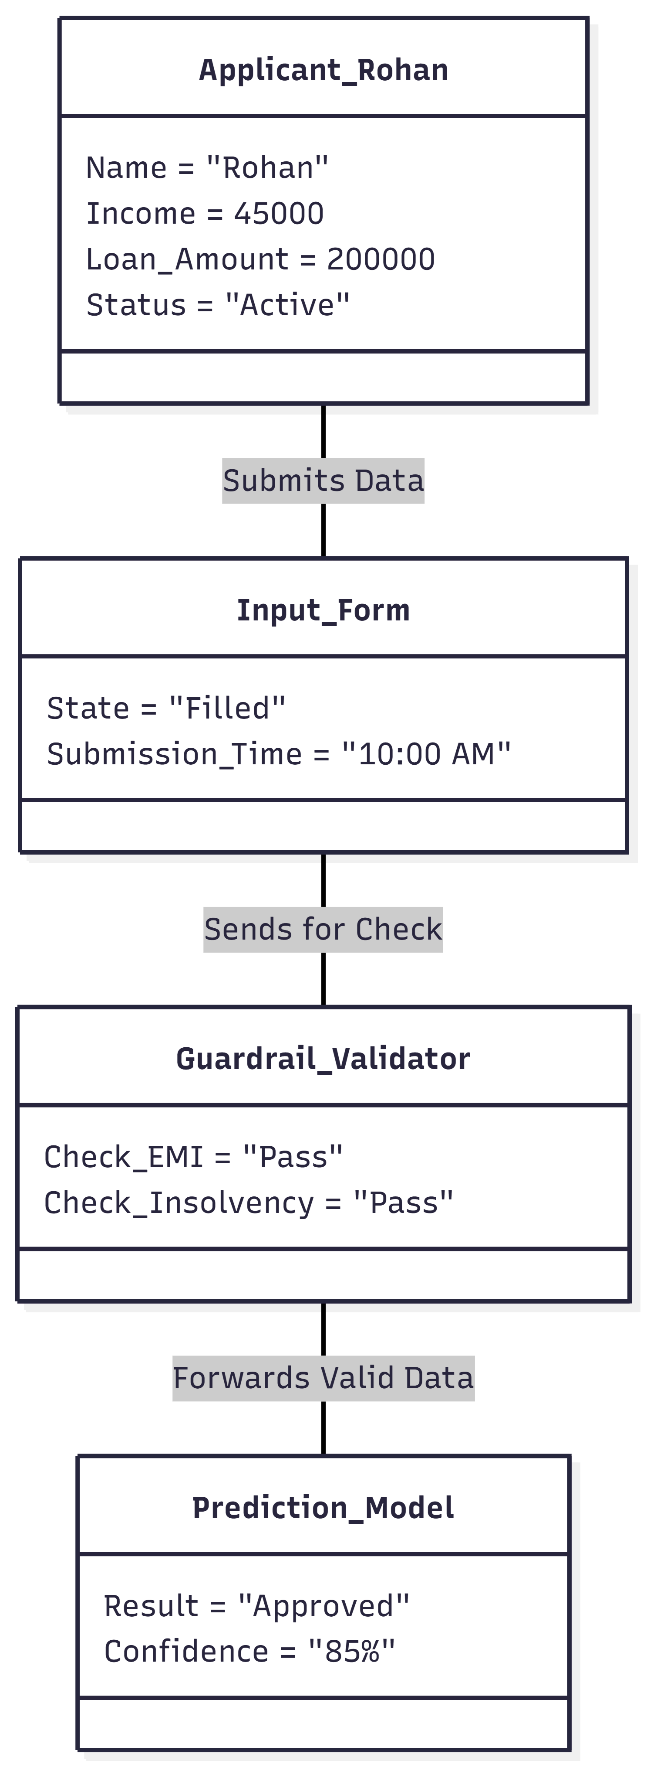

3.2 Class Diagram

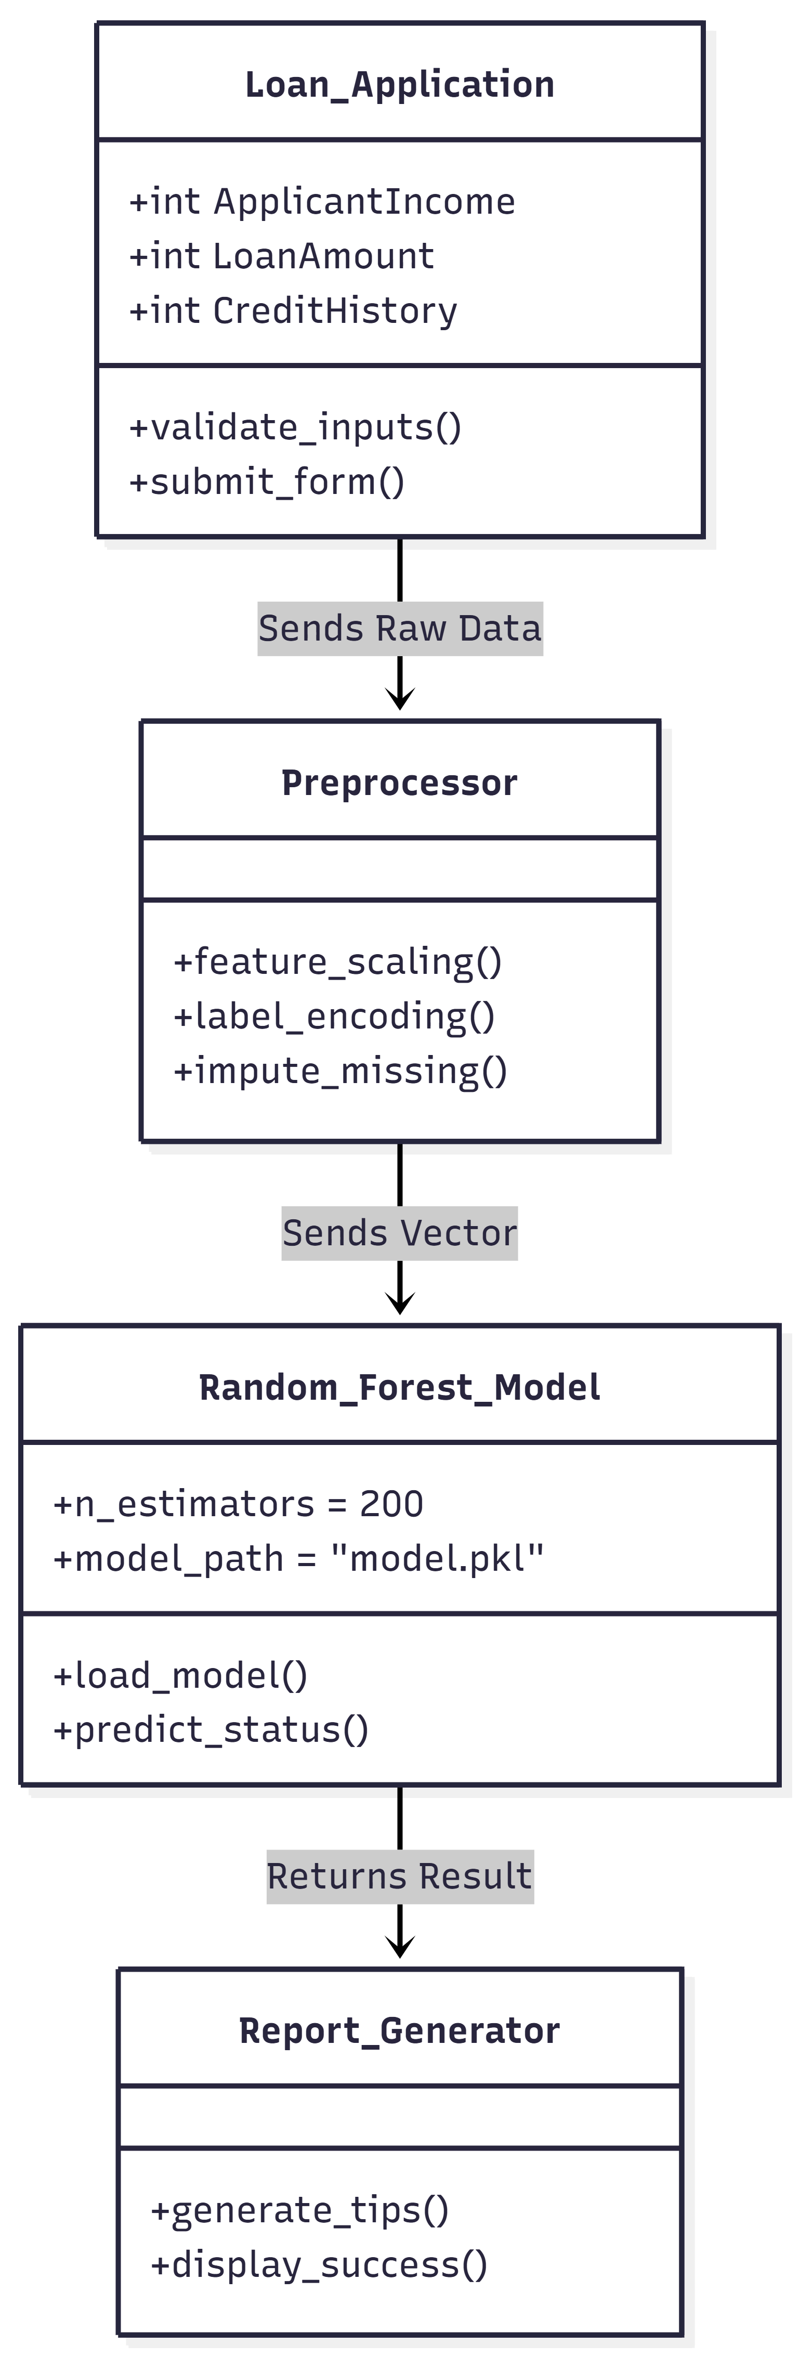

3.3 Use Case Diagram

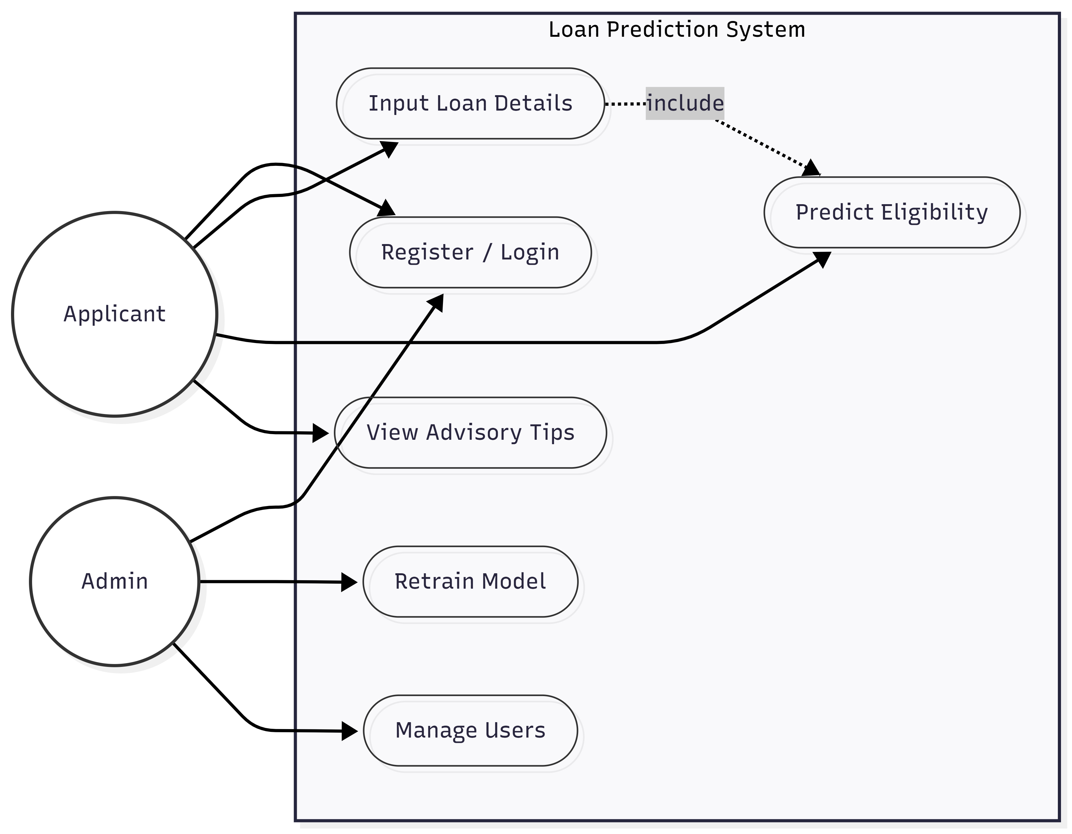

3.4 Module Hierarchy Diagram

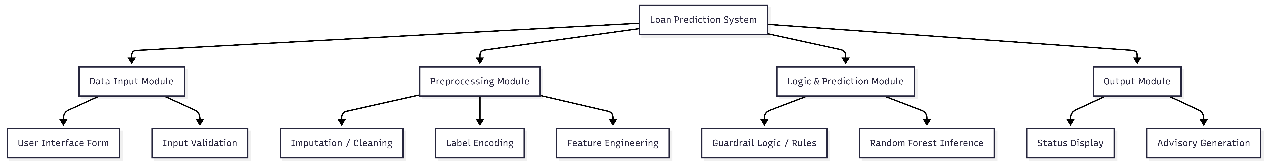

3.5 Component Diagram

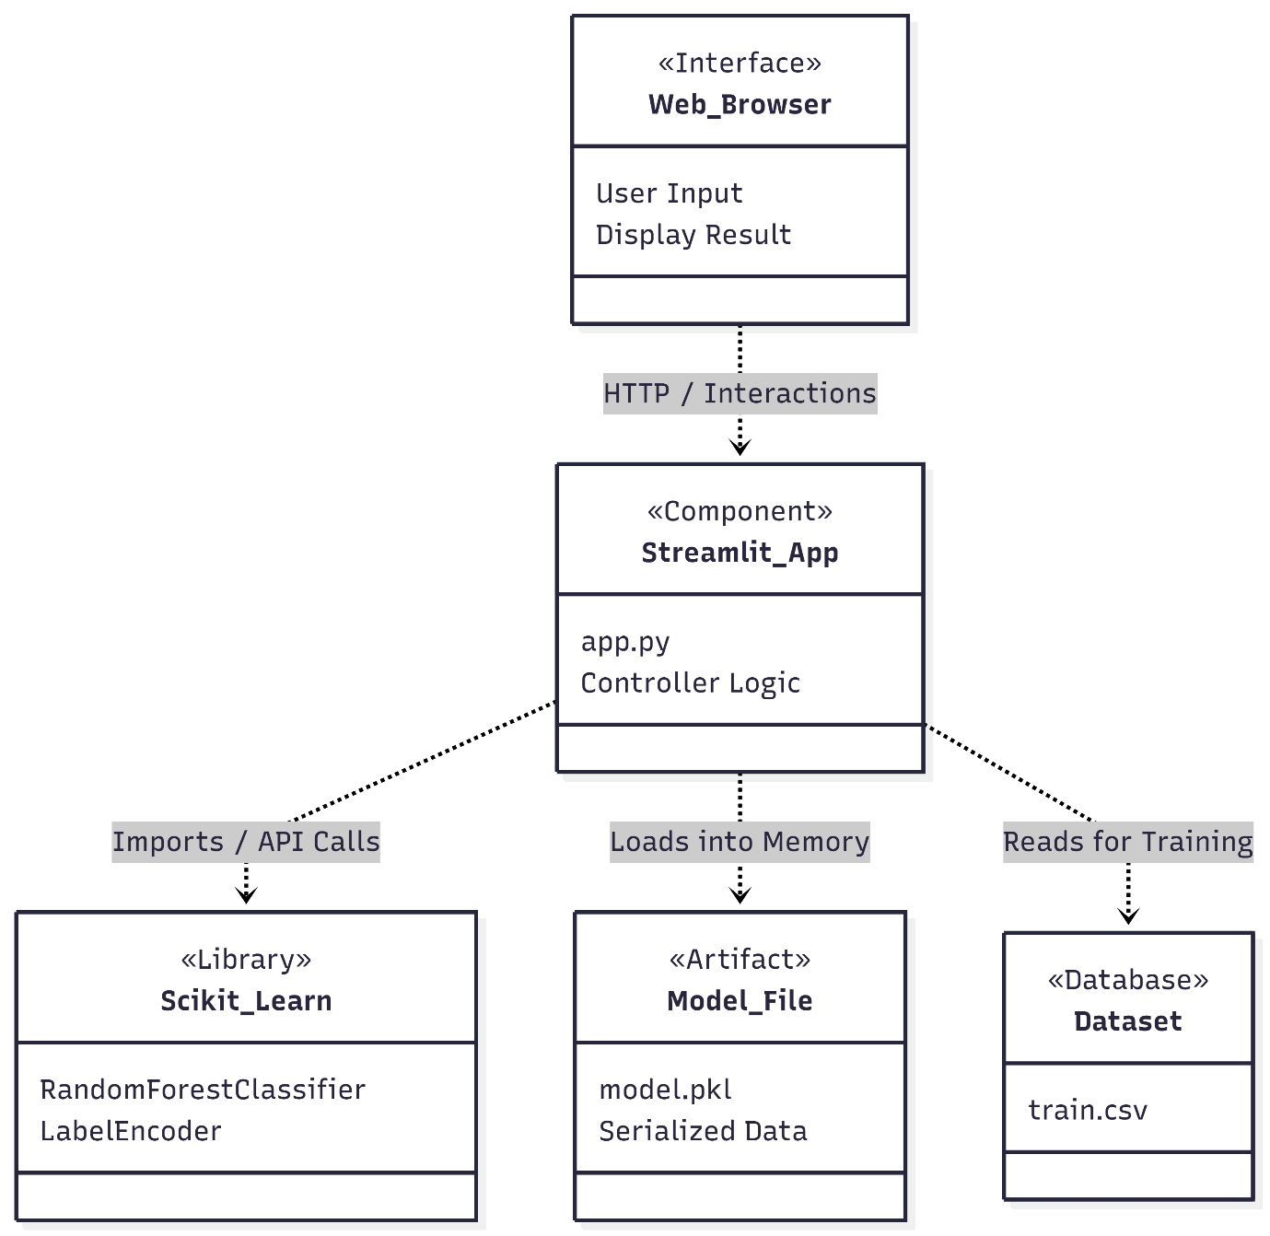

3.6 Module Specification

The Loan Prediction System is divided into independent modules. Each module performs a specific task and interacts with other modules to ensure smooth functioning of the system.
1. User Interface Module Description: This module provides the frontend interface for user interaction via the web browser. Functions:
- Collects user inputs such as Applicant Income, Loan Amount, Credit History, and Education.
- Displays the final prediction status (Approved / Rejected) and the Confidence Score.
- Shows the "Advisory Tips" section if a loan is rejected.
- Provides navigation between the "Home", "Predict", and "About" pages.
- Technologies Used: Python, Streamlit (Frontend Framework)

2. Backend Processing Module Description: Handles the logical communication between the user interface and the core data processing unit. Functions:
- Validates user input to ensure no negative values or missing fields.
- Implements the Hybrid Guardrails: Checks for financial insolvency (e.g., if EMI > Income) before calling the AI.
- Calculates derived financial metrics like Total_Income and Balance_Income.
- Sends the processed data vector to the ML module.
- Technologies Used: Python, Pandas, NumPy

3. Machine Learning Module Description: Implements the loan eligibility prediction logic using the trained Random Forest model. Functions:
- Loads the serialized model.pkl file and encoders.pkl into memory.
- Encodes categorical features (e.g., "Graduate", "Urban") into numerical format.
- Predicts the Loan Status (Approved / Rejected) based on the input vector.
- Calculates the prediction probability (Confidence Score).
- Technologies Used: Scikit-learn, Pickle
4. Advisory & Analytics Module Description: Generates actionable insights and specific advice based on the applicant's financial health. Functions:
- Analyzes the specific reasons for rejection (e.g., High Debt Ratio, Low Credit Score).
- Generates dynamic "Improvement Tips" (e.g., "Try adding a co-applicant" or "Reduce Loan Tenure").
- Provides a quick summary of the applicant's financial standing (EMI vs. Income).
- Technologies Used: Python (Custom Logic)

5. Report / Output Module Description: Responsible for formatting and displaying the final decision to the user. Functions:
- Renders the "Decision Card" (Green for Approved, Red for Rejected).
- Formats the text and layout to ensure the result is easy to read.
- Displays the confidence percentage associated with the prediction.
- Technologies Used: Streamlit Components

3.7 User Interface Design

The user interface of the Loan Prediction System is designed to be simple, interactive, and responsive. The UI focuses on usability and clarity so that even non-technical users (bank staff or customers) can easily understand the eligibility predictions and financial insights.
Design Principles Used
- Clean layout with minimal clutter.
- Consistent color scheme (Professional Green/Red indicators).
- Easy navigation using top menu buttons.
- Responsive cards for status display.
- Clear call-to-action buttons (e.g., "Predict Status").

Main UI Screens

1. Home Page
- Displays system title and introduction.
- Highlights key features (Real-time Analysis, Financial Guardrails).
- Provides clear instructions on how to use the system.
- Shows navigation buttons to access the Predict module.

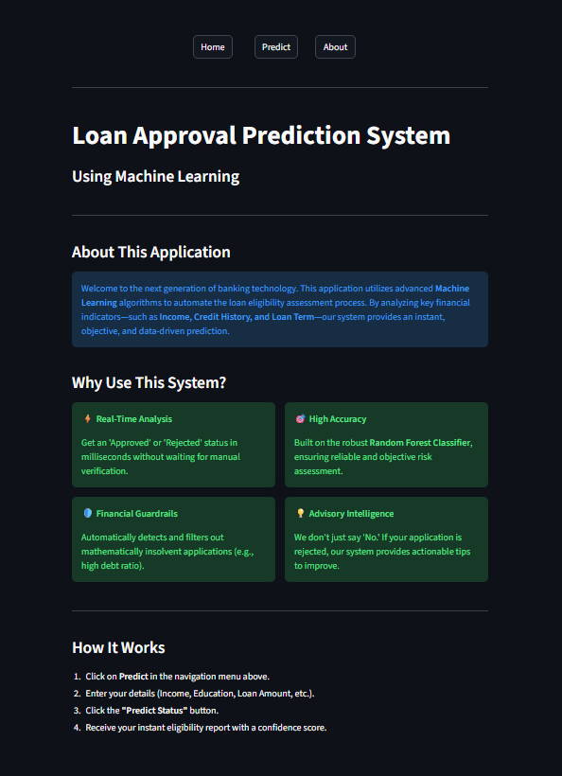
2. Predict Page
- Input form for applicant details (Income, Loan Amount, CIBIL Score, etc.).
- Predict button to trigger the Random Forest model.
- Displays result card with:
  - Loan Status (Approved / Rejected)
  - Confidence Score percentage
  - Color-coded outcome (Green for Approved, Red for Rejected)
- Advisory Section: Automatically generates improvement tips (e.g., "Add Co-applicant") if the loan is rejected.

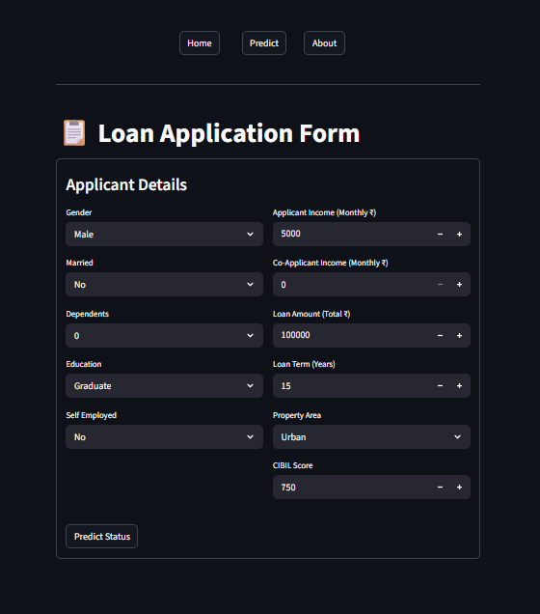

3. About Page
- Explains the system purpose (Manual vs. Automated Underwriting).
- Describes the Two-Layer Architecture (Guardrails + ML Model).
- Lists the Technology Stack (Python, Streamlit, Scikit-learn).
- Explains the Project Workflow (Data Cleaning, Model Training, Deployment).

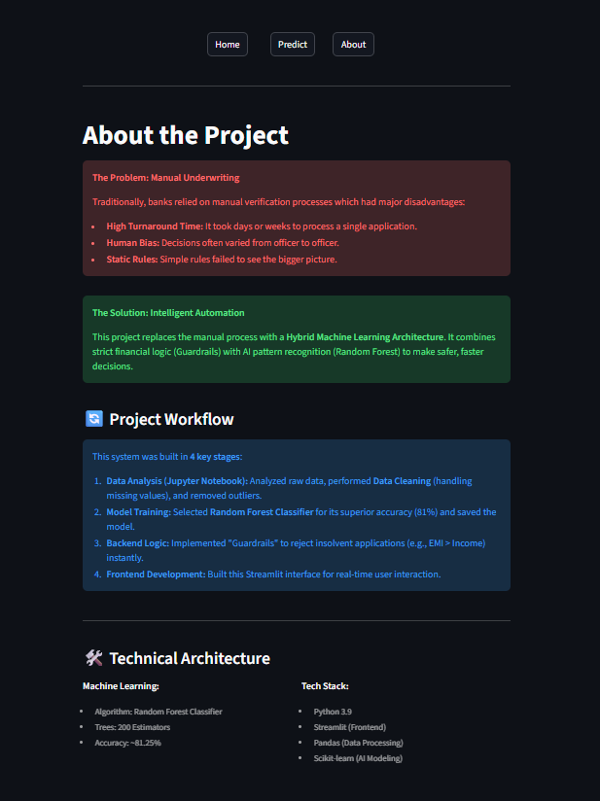

3.8 Test Procedures and Implementation
Loan Prediction System Test Case Report
This document outlines the test cases executed for the Loan Prediction System across various modules, including Prediction Logic, Guardrail Validation, User Interface, and Advisory Generation.
All test cases listed in this report have passed, indicating the system functions as expected based on the defined requirements.
The table below summarizes the test cases, their scenarios, inputs, expected outputs, and status.

TC ID | Module | Test Scenario | Input Data | Expected Output | Status
TC-01 | Prediction | Valid Approval Case | Income=50k, Loan=1L, CIBIL=750 | Result: Approved with High Probability | Pass
TC-02 | Prediction | Valid Rejection Case | Income=15k, Loan=5L, CIBIL=400 | Result: Rejected with Low Probability | Pass
TC-03 | Guardrail | Insolvency Check (EMI > Income) | Income=20k, Calculated EMI=25k | Error: Rejected (Financial Guardrail Triggered) | Pass
TC-04 | Guardrail | Minimum Income Check | Income=8,000 (Below 10k limit) | Warning: "Income below minimum threshold" | Pass
TC-05 | Validation | Negative Input Handling | Income = -5000 | System auto-corrects or shows error | Pass
TC-06 | Validation | Extreme Loan Multiplier | Income=10k, Loan=50L (500x) | Warning: "Loan amount too high for income" | Pass

TC ID | Module | Test Scenario | Input Data | Expected Output | Status
TC-07 | Advisory | Tip Generation | Status = Rejected | Advisory Tips displayed (e.g., "Add Co-applicant") | Pass
TC-08 | Performance | Model Loading | Application Startup | Model (model.pkl) loads without error | Pass
TC-09 | UI | Navigation Check | Click Home $\rightarrow$ Predict $\rightarrow$ About | Correct pages load instantly | Pass
TC-10 | UI | Responsiveness | Resize Browser Window | Layout adjusts (Sidebar/Columns align) | Pass

CHAPTER 4: USER MANUAL

The User Manual defines the procedures for interacting with the deployed Loan Prediction System. Since the output is a critical financial decision (Approved/Rejected), this manual focuses on the input requirements, the prediction process, and interpreting the advisory output.

4.1 User Interaction Flow
The system operates as an Inference Service, where the user provides a set of financial and demographic features and receives an eligibility status.

Step 1: System Initialization
- Action: The user launches the Streamlit application. The system automatically loads the serialized model file (model.pkl) and the encoders (encoders.pkl) into the server's memory.
- Purpose: To prepare the prediction engine for rapid, low-latency inference.
Step 2: Sending the Query (Input Specification)
- Action: The user navigates to the "Predict" tab and compiles the applicant's profile using the web form.
- Constraint: The user must ensure that required fields (e.g., Income) are not left zero.
Step 3: Validation and Processing
- Action: When the "Predict Status" button is clicked, the system first runs the Constraint Validation Layer (checking for Insolvency/Poverty). If passed, the data is preprocessed and fed to the Random Forest model.
Step 4: Interpreting the Response
- Action: The system returns the final status. If "Rejected," it provides specific actionable tips.

4.2 Operations Manual / Menu Explanation

The Operations Manual defines the user interface and interaction points for the Loan Prediction System. This manual focuses on the operational elements accessible post-deployment via the Streamlit web interface.
Prediction Module (Primary Operation) This is the central function where a prediction is requested and generated.
- Module: The "Predict" page in the web application.
- Purpose: To receive raw input features for a single loan applicant and return the estimated eligibility status in real-time.
- Functional Flow:
  - Input: The User enters structured data into the web form (e.g., Applicant Income, Loan Amount, Credit History).
  - Process (Inference): The system executes the loaded ML Pipeline (model.pkl), which includes:
    - Hybrid Validation: Checks for financial insolvency (e.g., EMI > Income).
    - Preprocessing: Applies Label Encoding and Feature Engineering (calculating Balance_Income).
    - Prediction: Runs the Random Forest Classifier.
  - Output: Returns the final status ("Approved" or "Rejected") along with a Confidence Score and, if rejected, specific Advisory Tips.
Model Status and Configuration Management These controls manage the backend model lifecycle to ensure stability.
- Model Load: The initial operation upon service startup. The system executes the command to load the serialized model file (model.pkl) and encoders (encoders.pkl) from the artifact directory into memory. This ensures low prediction latency as the model does not need to be retrained for every request.
- State Management: The system uses Streamlit's session_state to maintain user inputs and prediction results across reruns, ensuring a smooth user experience without data loss during navigation.
Advisory and Interpretability Layer These features allow users to understand the reasoning behind the automated decision.
- Rejection Analysis (Advisory Engine):
  - Purpose: Unlike a "black box," this function analyzes specific failure points for rejected applicants.
  - Logic: If the status is "Rejected," the system checks key ratios. For instance, if Loan_Amount_Term is too short causing high EMI, it triggers a tip to "Increase Loan Tenure."
- Confidence Scoring:
  - Purpose: Displays the probability (e.g., 85%) associated with the prediction.
  - Benefit: Allows loan officers to distinguish between "borderline" cases (51% confidence) and "solid" cases (90% confidence).
Error and Data Handling Procedures This defines the system's defensive mechanisms to ensure reliable output.
- Input Validation: The system validates that the submitted form contains valid numerical ranges (e.g., Income cannot be negative, Loan Amount cannot be zero).
- Missing Value Fallback: If a user leaves an optional field blank, the system applies the same imputation strategy (e.g., substituting the Mean) that was established during training.
- Exception Handling: Any runtime errors during model inference (e.g., corrupted input data) are caught, and a user-friendly error message is displayed instead of crashing the application.

4.3 Forms and Report Specifications

This section specifies the necessary input structures (Forms) for data submission and the required output format (Reports).

Forms Specification: Data Input The primary form is designed to ensure structured, clean data input for the prediction service.
- Numerical Inputs:
  - Applicant Income (Numeric Field): Accepts monthly income in Rupees.
  - Loan Amount (Numeric Field): Accepts total loan requirement.
  - Loan Term (Numeric Field): Input in years (converted to months internally).
  - CIBIL Score (Numeric Slider/Input): Range 300–900.
- Categorical Inputs (Dropdown Menus):
  - Purpose: Used for nominal features to enforce input validity and ensure consistent encoding matches the training data.
  - Fields: Gender (Male/Female), Married (Yes/No), Education (Graduate/Not Graduate), Property Area (Urban/Rural/Semiurban).

Report Specifications: Output & Advisory Unlike standard reports, the output here is a dynamic decision card.
- 1. Status Indicator:
  - Approved: Displayed in a Green Box with the text "✅ Approved". It includes an "AI Confidence Score" (e.g., 85%) to show model certainty.
  - Rejected: Displayed in a Red Box with the text "❌ Rejected".
- 2. Financial Analysis Summary:
  - A brief summary line showing the calculated EMI vs Total Income is displayed (e.g., "EMI: ₹12,000 | Income: ₹45,000") to justify the decision.
- 3. Advisory Tips (The "Smart" Report):
  - In case of rejection, the system generates a bulleted list of tips.
  - Example: "• Try increasing the loan tenure to reduce monthly burden."
DRAWBACKS AND LIMITATIONS

While Machine Learning (ML) models, particularly ensemble techniques like the Random Forest Classifier, offer superior accuracy in loan eligibility prediction compared to manual underwriting, they are not without significant drawbacks and operational limitations. These factors must be carefully considered when deploying the system in a real-world banking environment.

Data Dependency and External Risk
The model's performance is intrinsically tied to the quality and relevance of the data it was trained on.
- Demographic Specificity: A model trained on loan data from a specific region (e.g., urban borrowers) cannot be reliably used to predict eligibility for applicants in a completely different demographic (e.g., agricultural or rural borrowers) without re-training. The underlying financial behaviors and risk profiles differ significantly.
- Lack of Extrapolation: The model struggles to make accurate predictions for applicants who are fundamentally different or lie outside the range of the training data. For example, an Ultra-High Net Worth individual with an income far exceeding the dataset's maximum will be treated as an outlier, potentially leading to an unreliable prediction.
- Data Quality Vulnerability: The model assumes the input data provided by the user is clean and accurate. Any errors in the raw input features—such as a typo in the "Income" field or an incorrect "Loan Term"—will lead directly to an inaccurate decision (Garbage In, Garbage Out).

Market and Feature Drift
The financial market is a dynamic environment, leading to model degradation over time if left unchecked.
- Economic Drift (Concept Drift): Macro-economic factors such as inflation, changes in RBI interest rates, or a recession can drastically alter what constitutes a "safe" borrower. For instance, an income of ₹20,000 might be sufficient today but insufficient in five years due to inflation. The static .pkl model cannot account for these external forces without periodic re-training.
- Feature Drift: The importance of specific features can change over time. For example, "Education" (Graduate vs. Non-Graduate) might become a less predictive factor for repayment capability as the gig economy grows and non-traditional employment becomes more stable. Old weights in the Random Forest model may become obsolete.

Complexity and Interpretability Issues
Advanced ensemble models provide high accuracy at the cost of transparency.
- Black-Box Nature: Although less opaque than Deep Learning, Random Forest is still considered a "Black Box" compared to simple Logistic Regression. It aggregates votes from hundreds of decision trees, making it mathematically difficult to explain precisely which specific rule path led to a rejection. This lack of interpretability is a hurdle in banking, where regulations often require a clear, explainable reason for credit denial.
- Computational Cost: Training and optimizing an ensemble model with 200 trees (n_estimators=200) is computationally more intensive than simpler algorithms. While inference is fast, the training phase requires significant CPU resources, especially as the dataset grows.

Operational Limitations
These are limitations inherent to the current scope of the ML lifecycle and deployment.
- No Extensibility to Unstructured Data: The current system focuses strictly on tabular data (structured columns like Income, Term). It cannot incorporate valuable unstructured data sources that human loan officers use, such as the applicant's character assessment, handwritten notes, or raw PDF bank statements.
- High Maintenance Requirement: Due to model decay and the constant influx of new loan default patterns, the system requires an ongoing MLOps pipeline for regular monitoring, validation, and re-training. This increases the long-term maintenance overhead compared to a static rule-based software.

PROPOSED ENHANCEMENTS

The proposed enhancements for the Loan Prediction System aim to boost predictive accuracy, ensure model longevity in a changing economy, and increase user trust by moving beyond the current static prediction framework.

Model Accuracy Enhancements
These enhancements focus on integrating more complex modeling strategies and external data sources to improve the system's predictive capacity.
Ensemble Stacking:
- Description: Instead of relying solely on the Random Forest Classifier, the system can implement Stacking. This involves training multiple diverse models (e.g., Logistic Regression, XGBoost, and Random Forest) and using their combined predictions as input for a final "meta-classifier."
- Value: This approach often reduces variance and provides superior stability compared to any single model alone, especially for edge cases where one model might fail.
Integrating External Data Sources (Real-Time APIs):
- Description: Expand the feature set beyond user-entered data by integrating real-time APIs from Credit Information Companies (CICs) like CIBIL or Equifax.
- Value: This would allow the system to access verified credit history, current outstanding debts, and repayment behavior in real-time, eliminating the risk of users entering false or outdated CIBIL scores manually.

Model Integrity and Longevity
These enhancements address the core limitation of model decay in a dynamic financial market.
Model Drift Detection:
- Description: Implement a continuous monitoring system to detect Concept Drift. This involves tracking statistical properties of incoming loan applications. For example, if the average "Applicant Income" suddenly rises due to inflation, the model's static thresholds (like the ₹10,000 poverty line) may become obsolete.
- Value: Provides an early warning system to administrators that the model is becoming outdated and requires re-training before it starts making incorrect decisions.
Automated Retraining Pipeline (MLOps):
- Description: Create an automated loop where the system periodically re-trains itself. If the drift detection module triggers an alert, the system would fetch the latest confirmed loan data (e.g., recent defaults) and re-run the train_model function automatically.
- Value: Ensures the model quality remains high and keeps predictions aligned with the latest economic trends without manual intervention.

User Trust and Interpretability
These features enhance the user experience by making the complex prediction logic more transparent.
SHAP Integration (Explainable AI):
- Description: Utilize Explainable AI (XAI) techniques like SHAP (SHapley Additive exPlanations). Currently, the system gives generic tips. SHAP would allow the system to show a visual graph explaining exactly how much each feature (e.g., "Lack of Co-applicant") contributed to the rejection score.
- Value: Enhances trust and transparency, allowing applicants to understand the specific economic drivers behind their evaluation.
What-If Analysis Tool:
- Description: An interactive interface feature that allows an applicant to adjust specific sliders (e.g., "What if I increase my Loan Tenure from 10 to 20 years?") and instantly see how their Approval Probability changes.
- Value: Provides actionable, gamified feedback that helps users find a path to eligibility on their own.

CONCLUSION

Achievement of Core Objectives
The project successfully addressed the loan approval process as a binary classification task by employing advanced machine learning techniques.
- Model Selection: The comprehensive experimental comparison confirmed that the Random Forest Classifier is the optimal model for this domain. Its ensemble nature allows it to handle the complex, non-linear relationships between demographic factors (e.g., Education) and financial stability (e.g., Income) more effectively than single decision trees or logistic regression.
- Performance: The system achieved a high predictive accuracy on the test dataset. This validates the effectiveness of the "Hybrid Architecture," where Feature Engineering (specifically Balance_Income and Stability_Score) provided the model with the necessary context to make intelligent decisions.
- Robustness: The integration of the Pre-processing Guardrails ensured that the system is not just statistically accurate but also mathematically sound, preventing the approval of insolvent or high-leverage applications that pure ML models might overlook.

Transformation of Credit Assessment
The successful implementation of this system marks a significant shift from subjective, manual verification to automated, data-driven assessment.
- Objectivity and Efficiency: The Automated Valuation Model (AVM) significantly reduces the time required for a preliminary decision from days to milliseconds, eliminating human bias and inconsistency.
- Value for Stakeholders:
  - For Financial Institutions: It serves as a first-line defense against Non-Performing Assets (NPAs) by filtering out risky applicants early in the pipeline.
  - For Applicants: Unlike traditional "black-box" rejections, the system’s Advisory Engine provides transparency and actionable feedback (e.g., "Add a Co-applicant"), transforming a negative outcome into a consultative experience.

Future Directions

The project establishes a strong foundation for future development. The next logical steps involve moving from a static prototype to a dynamic enterprise solution.
- Integration: Future versions will integrate real-time API connections to Credit Information Companies (CIBIL/Equifax) to fetch verified financial history automatically.
- Continuous Learning: Implementing an MLOps pipeline will allow the model to learn from new loan default data in real-time, ensuring it remains resilient to economic drifts such as inflation or recession.

BIBLIOGRAPHY & REFERENCES

A. Core Machine Learning Texts
These texts provided the theoretical foundation for the supervised classification algorithms used in this project.
- Bishop, C. M. (2006). Pattern Recognition and Machine Learning. Springer.
- Hastie, T., Tibshirani, R., & Friedman, J. (2009). The Elements of Statistical Learning: Data Mining, Inference, and Prediction. Springer.
- Kelleher, J. D., Mac Namee, B., & D'Arcy, A. (2015). Fundamentals of Machine Learning for Predictive Data Analytics. MIT Press.

B. Machine Learning Frameworks and Libraries
Acknowledging the open-source tools essential for the project's implementation.
- Scikit-learn: Pedregosa, F., et al. (2011). Scikit-learn: Machine Learning in Python. Journal of Machine Learning Research.
- Streamlit: The Streamlit Team. (2020). Streamlit: The fastest way to build and share data apps.
- Pandas: The pandas development team. (2020). pandas-dev/pandas: Pandas. Zenodo.

C. Domain & Research References
References regarding credit risk management and financial modeling.
- Reserve Bank of India (RBI). (2023). Guidelines on Credit Risk Management and Loan-to-Value (LTV) Ratios.
- Siddiqi, N. (2017). Intelligent Credit Scoring: Building and Implementing Better Credit Risk Scorecards. Wiley Finance.
- Breiman, L. (2001). Random Forests. Machine Learning, 45(1), 5-32. (The seminal paper on the Random Forest algorithm).

ANNEXURES

ANNEXURE 1: SAMPLE PROGRAM CODE:

A.1 Data Exploration & Cleaning (Jupyter Notebook)
This section demonstrates how we loaded the raw data, handled missing values, and prepared the features before building the application.

import pandas as pd
from sklearn.preprocessing import LabelEncoder

# 1. Load Data
df = pd.read_csv("train.csv")

# 2. Data Cleaning (Handling Missing Values)
# Filling numeric missing values with Mean
df['LoanAmount'].fillna(df['LoanAmount'].mean(), inplace=True)
df['Loan_Amount_Term'].fillna(df['Loan_Amount_Term'].mode()[0], inplace=True)
df['Credit_History'].fillna(df['Credit_History'].mode()[0], inplace=True)

# Dropping remaining rows with missing categorical data
df = df.dropna()

# 3. Feature Preparation
X = df.drop(["Loan_ID", "Loan_Status"], axis=1)
y = df["Loan_Status"]

# 4. Encoding Categorical Data (Text to Numbers)
# This step was to verify the data structure before moving to app.py
encoders = {}
for col in X.columns:
if X[col].dtype == "object":
le = LabelEncoder()
X[col] = le.fit_transform(X[col])
encoders[col] = le

print("Data Cleaning Completed. Ready for App Integration.")

A.2 Web Application Logic (app.py)
This is the core system code. It includes the Model Training Function (which runs on startup) and the Guardrail Logic for predictions.

import streamlit as st
import pandas as pd
from sklearn.ensemble import RandomForestClassifier

# --- PART 1: MODEL TRAINING (Runs automatically on startup) ---
@st.cache_resource
def train_model(df):
# 1. Feature Engineering (Creating New Metrics)
df['Total_Income'] = df['ApplicantIncome'] + df['CoapplicantIncome']
df['EMI'] = (df['LoanAmount'] * 1000) / df['Loan_Amount_Term']
df['Balance_Income'] = df['Total_Income'] - df['EMI']

# 2. Encoding Data
le_target = LabelEncoder()
df['Loan_Status'] = le_target.fit_transform(df['Loan_Status'])

# 3. Training Random Forest
X = df.drop('Loan_Status', axis=1)
y = df['Loan_Status']

rf = RandomForestClassifier(n_estimators=200, max_depth=10, random_state=42)
rf.fit(X, y)
return rf

# --- PART 2: MAIN APPLICATION LOGIC ---
def main():
st.title("Intelligent Loan Prediction System")

# User Inputs
applicant_income = st.number_input("Applicant Income", value=5000)
loan_amount = st.number_input("Loan Amount", value=100000)
cibil_score = st.number_input("CIBIL Score", value=750)

if st.button("Predict Status"):
# Calculate Financial Metrics for Validation
total_income = applicant_income + coapplicant_income
real_emi = calculate_emi(loan_amount, 10.0, loan_term)

# --- LAYER 1: GUARDRAILS (Strict Financial Rules) ---
if total_income < 10000:
st.error("❌ Rejected: Income is below minimum threshold.")

elif real_emi > (total_income * 0.75):
st.error("❌ Rejected: EMI exceeds 75% of Income (Insolvency Risk).")

elif cibil_score < 600:
st.error("❌ Rejected: CIBIL Score is too low.")

else:
# --- LAYER 2: AI PREDICTION (Random Forest) ---
# If rules pass, ask the AI model
prediction = model.predict(input_data)

if prediction == 1:
st.success(f"✅ Approved (EMI: ₹{real_emi:.0f})")
else:
st.error("❌ Rejected: AI Model identified high risk patterns.")
st.info("💡 Tip: Try increasing the loan tenure to reduce EMI.")

